As this VM is going to run server services like Apache2 (Web

Server) and MySQL (Database Server) etc., it is good to fix its

IP address.

I will set this Ubuntu Server VM to use static IP address, and

the address is 192.168.80.188.

The rest of the IP settings will remain as it is.

11. Setting static requires a good working knowledge to configure

some network configuration files. It is not simple as ABC, and

you may make mistakes.

I am going to use NetworkManager instead, which allows me to

use GUI to do the necessary changes.

First I need to edit the file /etc/netplan/50-cloud-init.yaml,

and add the following line:

renderer: NetworkManager

sudo gedit /etc/netplan/50-cloud-init.yaml



Then run sudo netplan apply, to effect the change.

sudo netplan apply

Restart your Ubuntu VM.

12. Once Network Manager is set as the network renderer should be

able to see the network icon on the top right of your desktop.

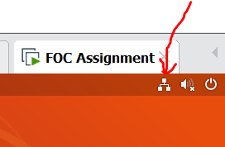

13. Click on the network icon and select Wired Connect >> Wired

Settings.

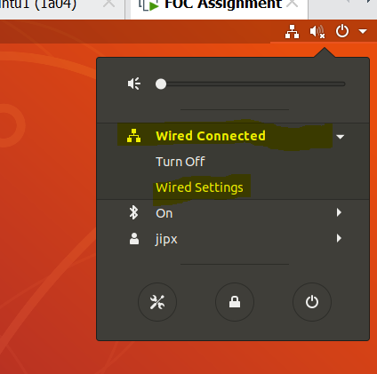

14. Click on the "gear" icon to view current network settings.

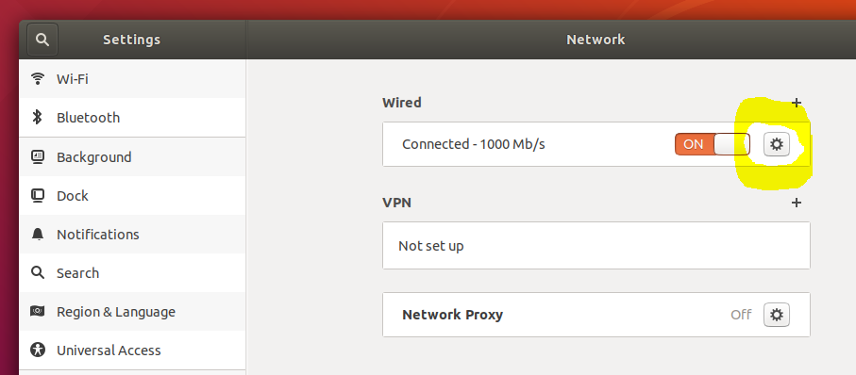

15.Below are the current IP settings, obtained from DHCP server.

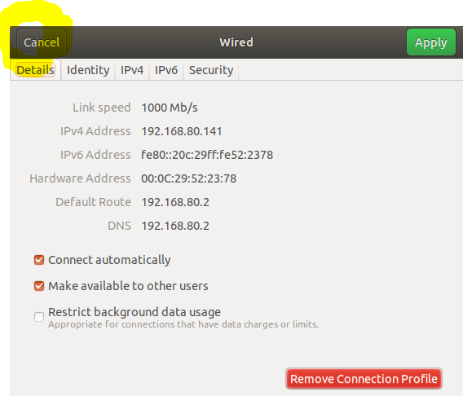

Click "Cancel" to close the window.

16.Click on "+" to create a profile, where we will set our Ubuntu

Server to use static IP address (not dynamic using DHCP).

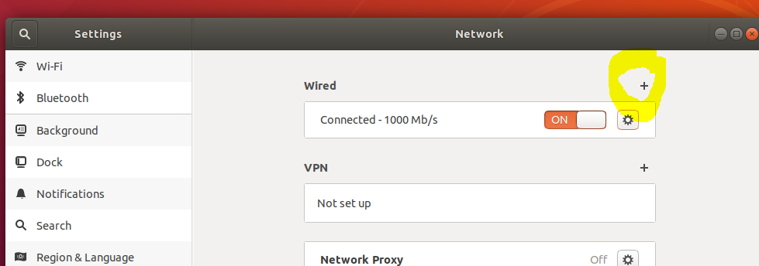

17.Change the profile name from "Profile 1" to "Static". Then

switch to "IPv4" tab.

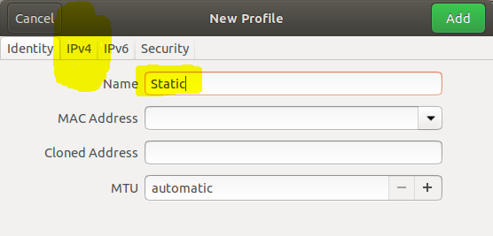

18.Select "Manual" for IPv4 Method.

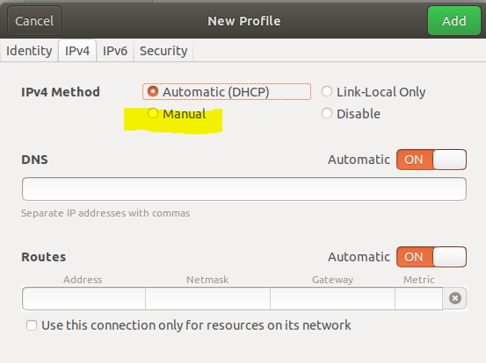

19.Enter the IP address, Netmask, Gateway, DNS and set DNS

Automatic to OFF.

Then click on "Add" to add this profile.

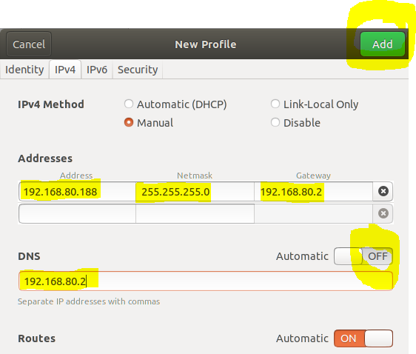

20.Click on the "Static" profile to activate it, and set this as

default profile to use when you start your VM.

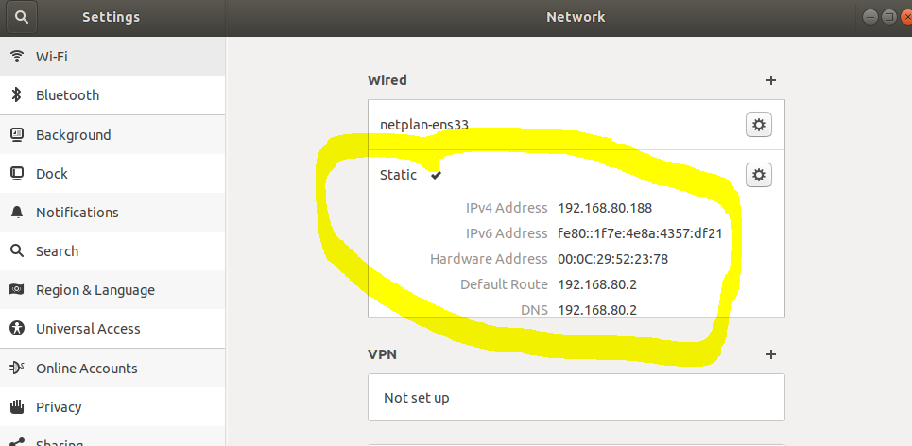

You can now see that profile "Static" is activated. Close the

window when done.

21.The profile "Static" is store in the file -

/etc/NetworkManager/system-connections/Static

You can view the content of this file using the cat command

below:

sudo cat /etc/NetworkManager/system-connections/Static

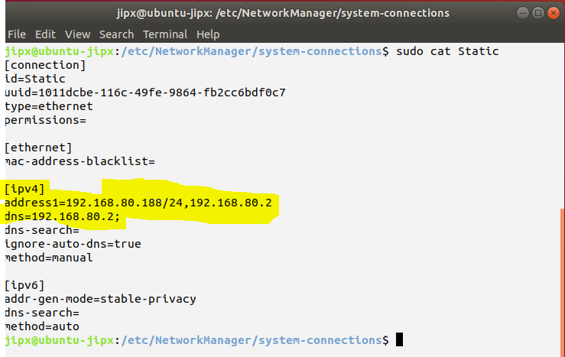

22.The current hostname is "ubuntu-jipx". I want to change it to

"s56465".

In your assignment you are supposed to change it to pnnnnnn,

where nnnnnnn is your admission number.

To change the hostname, you need to edit these two files:

/etc/hostname

/etc/hosts

Edit the files, using gedit or nano, accordingly as follows:

sudo gedit /etc/hostname

sudo gedit /etc/hosts

The file /etc/hostname should look like this after editing:

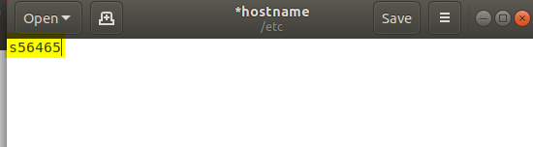

The file /etc/hosts should look like this after editing:

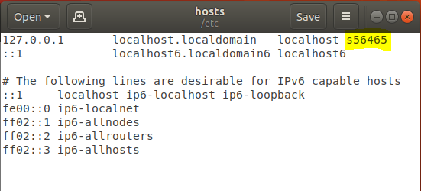

23. Restart your VM.

After restarting, run the command “hostname” to confirm that

Your VM’s hostname is changed.